**Super class and Sub class and super ( ) method**

Super class is the one step above class

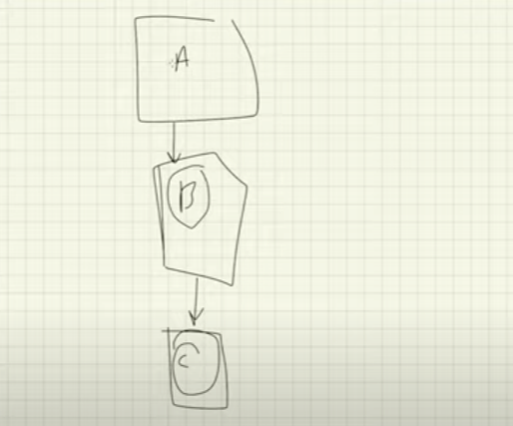

Here A is super class of B and B is sub class of A

Here B is super class of C and C is sub class of B

super( ) used in sub class C will call the constructor( ) of it’s super class B

Also

super ( ) used in class B will call the constructor( )of it’s super class A

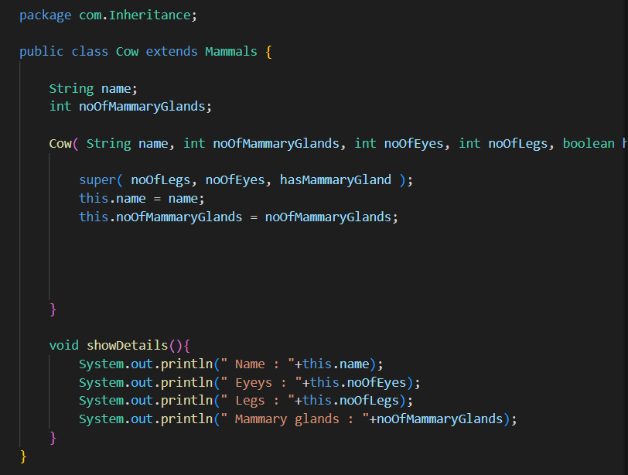

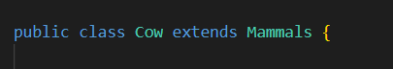

Here Mammals is super class and Cow is sub class

We can access the properties of super class in sub class using super keyword instead of this, actually this is best practice since it let us know that we are accessing the properties of the super class

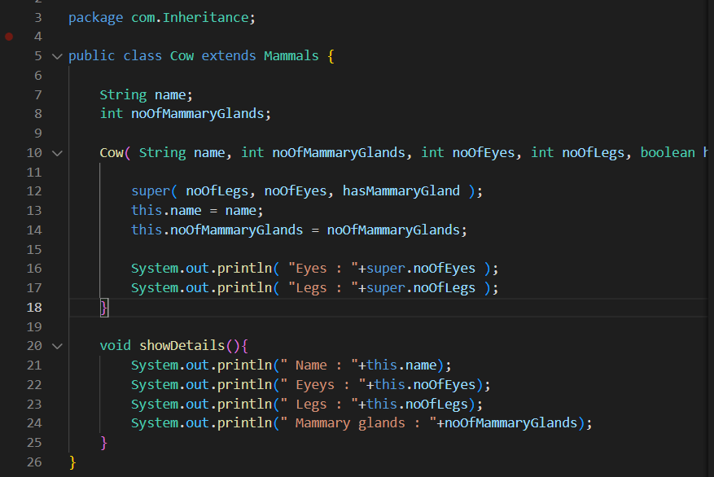

Hers in line 16 and 17 we are accessing the properties of the super class using super keyword in the sub class